Week 1 Lesson 2
Nanotechnology
Aim: To understand what nanotechnology is, recognise some nanomaterials that have already been made and consider possible future developments.
Keywords: nanotechnology, prefixes, nanoparticles, atoms, nanotubes

Starter activities
- Large and small prefixes
Ask students to recall the base units from the first lesson and examples of compound units such as speed. There is a paper based and an interactive version of the activity ‘Large and small prefixes’, which gives students clues to put the prefixes into the correct order of size.
Explain that in science we use numbers which are very large; number of bytes on a hard drive, population size of bacteria, number of stars in a galaxy, or numbers which are very small such as the size of molecules and the distance between nerve cells. To make these numbers manageable scientists use prefixes in front of the unit, e.g. kilometre = 1 000 metres.
Assessment opportunity
The activity can be used to assess students’ knowledge of the sequence of prefixes.
Give students the ‘Large and the small prefixes' resource to assess their understanding.
- Powers of ten
Suggested activities:
- Watch the Powers of 10 video on YouTube: www.youtube.com/watch?v=0fKBhvDjuy0.
- Use the PowerPoint, ‘Powers of ten’, to remind students about the use of powers when writing down very large and very small numbers.
Assessment opportunity
Check students’ understanding by using the interactive matching activities.
Explain that the 'm' for milli- is a prefix and would be attached to another symbol e.g. mm represents millimetre.
Main activity
- What is nanoscience and technology?
Use the resource ‘What is nanoscience and technology?’ in which students can explore the current developments in nanotechnology by questioning an ‘expert witness’ in a mock select committee.

Plenary activities
- Units and prefixes summary
Summarise everything they can remember about the units and prefixes discussed in this lesson. This could be done in a variety of ways depending on ability.
Differentiation:
Most support needed: Give students 2 or 3 columns of the table with some of the words/symbols included.
Medium support: Give students the table with headings but otherwise blank.
Least support: Students design their own method of presenting the information.

Extension:
Students challenge their partner to find an equivalent using the units kilometre, metre, millimetre, micrometre and nanometre to show relationships between them.
e.g. 1 km = 1 000 m; 1 mm = 1000 µm; 1 mm = 103 µm

- Why do scientists use prefixes and symbols?
Depending on ability ask students to do one of the following:
- List examples of how scientists save time by using prefixes, symbols and mathematical notations.
- Describe examples of how scientists save time by using prefixes, symbols and mathematical notations.
- Explain the relationships between some of the prefixes, symbols and mathematical notations used by scientists.
Starter 1
Large and small prefixes — Teaching notes
Students use the clues to arrange the prefixes in order, from largest to smallest. There is also an interactive version that can be used on interactive whiteboards.
Explain/discuss what a 'prefix' is. It is attached to another word to give more information about the word e.g. 'un' is a prefix which is attached to 'happy'.
Explain that these prefixes are attached to units such as 'metre' to show how large or small the unit is in relation to a metre.

Large and small prefixes — Answers
Prefix | Where I belong
tera | I am above kilo
giga | I am between tera and mega
mega | you’ll find me below giga
kilo | I am the median word in the list
milli | I belong above micro
micro | I am below milli
nano | there are 3 between me and mega

Large and small prefixes
Cut out the strips and use the clues to put the size prefixes in the correct order.

Prefix | Where I belong
giga | I am between tera and mega
micro | I am below milli
nano | there are 3 between me and mega
tera | I am above kilo
mega | you’ll find me below giga
milli | I belong above micro
kilo | I am the median word in the list

Main 1
What is nanoscience and technology? — Teaching notes
Introduction
One of the reasons why research using the principles of biomimicry has taken off in recent years is because of nanoscience and technology.

Many of the processes carried out by living things such as photosynthesis happen because the cells are able to manipulate molecules in very sophisticated ways.

In order for scientists to copy some of these techniques and processes, they also have to be able to control molecules and atoms. This manipulation was a very rare occurrence until the development of nanotechnology. Scientists are still developing and refining their techniques and much of the research is very new.
Show the students the clip How to make graphene: www.youtube.com/watch?v=PifL8bAybyc

Background information for main activity
Members of Parliament sit on Select Committees to gather evidence and make decisions about important issues of the day.

The members of the committee will have some background knowledge of the issue but they call upon various experts to provide greater detail and insight.

The video clip (www.parliament.uk/business/committees/committees-a-z/joint-select/national-security-strategy/news/evidence-from-the-prime-minister/) shows the layout of a committee room, with committee members seated around the horseshoe arrangement of desks and the expert seated in front of them. Just a couple of minutes viewing will give students an idea of the atmosphere and procedure in the committee room.

Each group of students will be a committee looking into the potential and implications of nanotechnology. They will do some preliminary research, completing the table below. Working in groups, students are given a limited time to seek out the sources of information which are spread around the room and use the information to complete their sheet.

The teacher will be the expert witness.

Groups will write 2 – 3 questions about the aspects of nanotechnology covered on the sheet (and they must have a good idea of the answer).

Taking it in turns, each group will ask you one of their questions.

Their question must cover a different aspect of the subject from the questions which have gone before, unless five questions have been asked, in which case they can start again.

The answer to their question must lie in the research information they used earlier. The expert witness may want to add in some errors or evasions to their responses to see how on the ball the committee members are.

What is nanoscience and technology? — Research form
What is nanotechnology?
Why are nanomaterials special?
What structures can be made?
Are they used in products today?
Are there any risks?

What is nanoscience and technology? — Information sheets

What is nanotechnology?
Nanotechnology is a technology developed by scientists and engineers, which uses and manipulates extremely small things like atoms and molecules.
Nanotechnology works at the scale of nanometres. It involves particles and structures 1 – 100 nm in size. A sheet of newspaper is 100 000 nm thick.

Why are nanomaterials special?
Nanomaterials are special because substances can have very unusual properties when investigated at the nanoscale. Gold nanoparticles are not yellow in colour but appear red or purple.
Some nanomaterials are special because they are stronger than the same material in bulk form. Others have different magnetic properties or they are more reactive. Others conduct heat or electricity differently.

What structures can be made?
Sheets, tubes and wires are structures which can be made.
Nanowires have a diameter as small as 1 nm.
Nanosheets consist of a single layer of atoms.
Nanotubes can be formed from sheets which have been rolled up.
The properties of nanotubes vary according to how the sheet is rolled.
Carbon nanotubes are hundreds of times stronger than steel but six times lighter.

Are they used in products today?
Self-cleaning glass contains nanoparticles which break down in UV light loosening dirt on the glass.
Materials can be coated in nanoparticles which are resistant to water (hydrophobic). Water beads up on the surface and simply rolls away taking dirt with it.
Tennis rackets have been constructed with carbon nanotubes making them stronger without increasing their weight.
Anti-microbial bandages contain nanoparticles of silver which coat harmful cells such as bacteria, killing them.
Scratch-resistant coatings with aluminium silicate nanoparticles help increase the resistance of materials to damage from scratches. These coatings are used in car manufacture and on glasses.
Many sunscreens contain zinc oxide or titanium oxide nanoparticles. These small particles ensure the layer of sunscreen on the skin is clear.

Are there any risks?
Comparatively little research has been carried out into the risks of this technology but people have expressed many fears. Remember these structures are very small. We cannot see them or filter them out of the air or water supplies.
Nanoscale particles could be toxic if breathed into the lungs.
The human brain is very efficient at keeping out substances that may be harmful to it. This happens at the blood-brain barrier. Nanoparticles may be able to cross this barrier and affect brain cells.
Nanoparticles will enter the soil, air and water supplies. No one knows the effects of them on the ecology and our environment.
Very tiny, yet very destructive weapons could be developed.
Molecular sized cameras and microphones could be developed to monitor people.

Main 2
Powers of 10 — PowerPoint

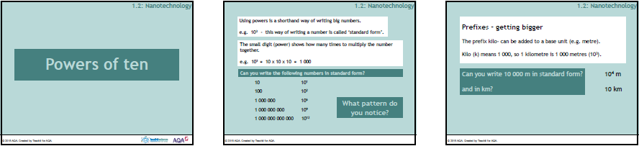

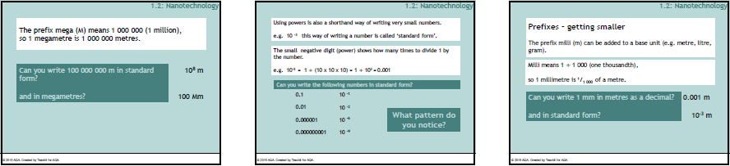

Plenary 1
Prefixes summary table
Complete the table.
Prefix | Symbol | Powers of 10
tera |  | 10¹²
 | G | 10⁹
mega | M
 | k | 10³
milli |  | 10⁻³
micro | µ
 |  | 10⁻⁹

Prefixes summary table
Complete the table to show the prefixes in order of size.
Prefix | Larger or smaller that the base unit e.g. metre | Symbol | Powers of 10
tera
 |  |  | 10⁻⁹

