Week 6 Lesson 1
Artificial photosynthesis (1)
Aim: to look at an example of scientific research inspired by nature, which is still in the developmental stage but which has enormous implications should it be successful.
Keywords: carbon dioxide, catalyst, chromatography, nanotechnology, oxygen, photosynthesis, water

Starter activity
- Introduction to energy sources
The PowerPoint, ‘Artificial photosynthesis – starter’ contains a series of discussion questions to choose from. Use them to introduce the search for alternative energy sources.

Main activities
- Practical – Is chlorophyll the only pigment in green leaves?
Artificial photosynthesis requires a method of splitting water molecules. Perhaps a pigment similar to chlorophyll could be produced.
Do the first part of 'Is chlorophyll the only pigment in green leaves?' allowing students plenty of time to spot chlorophyll onto their chromatogram. Stages 11 onwards can be completed during the following lesson.
Once the practical has been tidied away show ...
www.youtube.com/watch?v=UQNLdA2svjQ
Extension
The activity provides an extension activity in which students use their mathematical skills to calculate Rf values for the pigments.

Assessment opportunity
Assess students’ ability to put their measurements into an equation to make a calculation and give their answers to 3 decimal places.
- Artificial photosynthesis – obstacles
Do the ‘Artificial photosynthesis - obstacles to be overcome’ activity
Differentiation
Give students the crossword with some of the letters already filled in.

Plenary activity
- What am I?
The students are given clues to identify three substances involved in photosynthesis, see the PowerPoint ‘What am I?’.

Extension
Ask students to describe and explain the links between the three substances.

Main 1
Practical — is chlorophyll the only pigment in green leaves?
Apparatus
- 5-10 small spinach leaves
- Pestle and mortar
- pipette
- boiling tube
- spent match
- sticky tape
- strip of filter paper – slightly narrower but the same length as the tube
- sand
- ethanol

Method
- Cut the spinach leaves into small pieces and put into mortar.
- Add a pinch of sand to the mortar and grind leaves for 1 minute.
- Add 10ml ethanol to mortar. Leave 10 minutes for the chlorophyll to dissolve.
- Meanwhile with a ruler, draw a pencil line 2cm from one end of the filter paper.
- Draw a dot in the centre of the line.
- Wrap the other end of the filter paper around the spent match. Before securing with sticky tape, hang the paper inside the tube and check that it is about 1cm away from the bottom of the tube.
- Lift the match and remove the filter paper from the tube. Set it to one side.
- Using a pipette, draw up < 1ml of the chlorophyll ethanol mixture.
- Squeeze a small drop of this onto the dot on the pencil line. Allow to dry before adding another drop. Repeat for as long as time allows.
- Add 5ml of clear ethanol to the test tube.
- Hang the filter paper in the test tube. The end of the paper should be immersed in the ethanol but not the green spot. Leave for 20 minutes.
- Remove filter paper. Draw a pencil line to show the level of the solvent and leave to dry.
Results
Look carefully at the paper. Are there bands of different colours?
Measure the distance from the pencil line to the line showing the level of the solvent.
Measure the distance from the original line to the leading edge of the highest band of pigment.
Repeat this for each colour on the filter paper and write down all your measurements in centimetres.
Colour of pigment | Name of pigment
pale orange | carotene
blue-green | chlorophyll a
yellow-green | chlorophyll b
grey | phaeophytin
yellow | xanthophyll 1
yellow | xanthophyll 2

This experiment shows that there is more than one pigment used by plants in photosynthesis.
Only chlorophyll a is found in all green plants.

Questions:
- What is this method of separating a mixture called?
- Which substance is the solvent in this experiment?
- Which substances are the solutes?
- Using the keywords solvent, solute, soluble, insoluble, and solution explain why ethanol is added to the mortar and not water.
- Different solutes have different solubilities in a solvent such as ethanol. Why do you think some pigments travelled further up the filter paper?
Extension
There are two forms of the pigment xanthophyll. Both are yellow in colour. Your results may not have revealed this but sometimes two separate bands of yellow can be identified on the filter paper.
Scientists use a measurement called Rf to help distinguish different pigments on a chromatogram.
To calculate the Rf values for a pigment use this formula:
Rf = a ÷ b
Where...
a is the distance (in cm) moved by the pigment
and
b is the distance moved (in cm) by the solvent.
Different solvents will give different Rf values.
Complete the table below.
Colour of band | a  (cm) | b  (cm) | Rf value a ÷ b  (3 dp) | Name of pigment
orange | 8.2 | 8.6 | 8.2 ÷ 8.6 = 0.953 | carotene
green | 7.1 | 8.6 |  | chlorophyll a
green | 6.6 | 8.6 |  | chlorophyll b
yellow-grey |  | 8.6 | ÷ 8.6 = 0.616 | phaeophytin
yellow |  | 8.6 | ÷ 8.6 = 0.430 | xanthophyll 1
yellow |  | 8.6 | ÷ 8.6 = 0.372 | xanthophyll 2

Use the Rf values for the different pigments in the table above to work out which pigments are in the spinach cells you tested.
Colour of band | a  (cm) | b  (cm) | Rf value a ÷ b  (3 dp) | Name of pigment

Teaching notes
The practical activity should be carried out over two lessons. During the first lesson aim to get the first 9 steps completed so that students can put their chromatograms straight into the solvent at the start of the next lesson.
N.B. The appropriate risk assessment should be completed before carrying out the practical with students.

Answers
Colour of band | a = distance moved by pigment (cm) | b = distance moved by solvent (cm) | Rf value  a ÷ b  (3 dp) | Name of pigment
orange | 8.2 | 8.6 | 8.2 ÷ 8.6 = 0.953 | carotene
green | 7.1 | 8.6 | 7.1 ÷ 8.6 = 0.826 | chlorophyll a
green | 6.6 | 8.6 | 6.6 ÷ 8.6 = 0.767 | chlorophyll b
yellow-grey | 5.3 | 8.6 | 5.3 ÷ 8.6 = 0.616 | pheophytin
yellow | 3.7 | 8.6 | 3.7 ÷ 8.6 = 0.430 | xanthophyll 1
yellow | 3.2 | 8.6 | 3.2 ÷ 8.6 = 0.372 | xanthophyll 2

How to set up the chromatography experiment

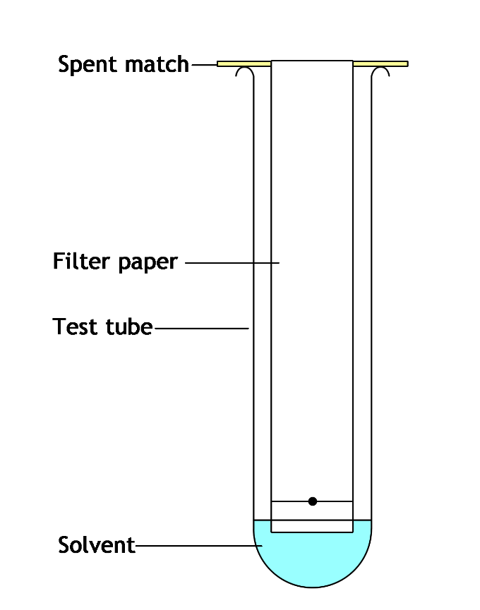

Measurements for Rf values

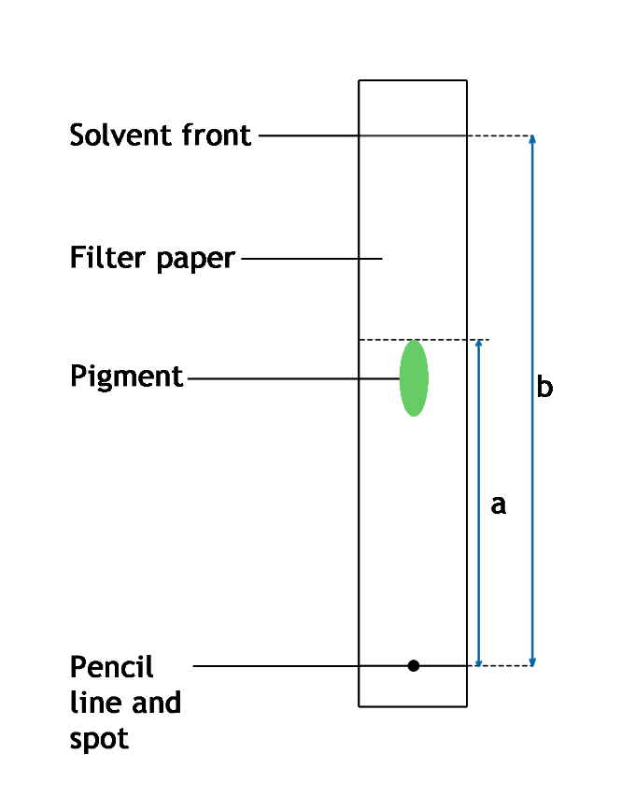
Main 2
Artificial photosynthesis - obstacles to be overcome
Task
Read the text below.

Artificial photosynthesis has been made to work in the laboratory but it cannot be scaled up for mass production. The structures and processes plants use to carry out photosynthesis have evolved over millions of years. They are extraordinarily complex and intricate and this is difficult to reproduce in the lab.
Plants use manganese as a catalyst for the chemical reactions which occur in chloroplasts during photosynthesis. Manganese does not work in the lab. It is rather unstable and does not dissolve in water. Researchers have tried other catalysts but these are also unstable and can cause extra, unwanted chemical reactions.
Some inorganic metal oxides have been tried as catalysts. Most of these do not work quickly enough or are in very short supply, making them too expensive to use.
Cobalt oxide however, looks promising. It is stable, catalyses a fast reaction and is an abundant compound.
In the most recent research into artificial photosynthesis, the catalyst has not been such a big problem. The main obstacle has been the solution which is used when molecules of water are split apart. This liquid is very corrosive and damages components in the apparatus.

This is rather complicated!
To make it easier to understand you will need a red, blue and green pencil.
Read the text again and use your coloured pencils to underline the following:
- the names of any catalysts you come across in red
- the problems connected to each catalyst in blue
- a problem which is not associated with a catalyst in green.
Now have a go at the questions below. Give one word answers. Use your answers to fill in the empty crossword puzzle.

Which element do plants use as a catalyst during photosynthesis?
Whereabouts would you find this element in a plant cell?
The oxide of which element has been successfully used as a catalyst in artificial photosynthesis?
Is manganese soluble or insoluble in water?

Four answers and clues are missing. Can you find four relevant words from the text to fill the gaps?
Write a clue for each.

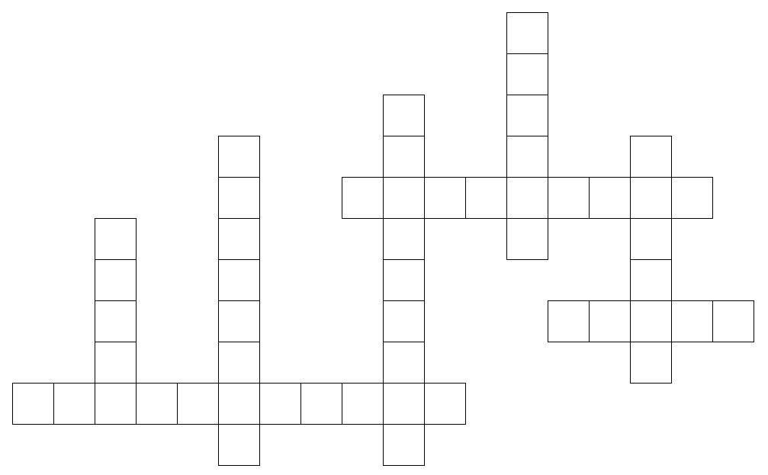

Crossword answers
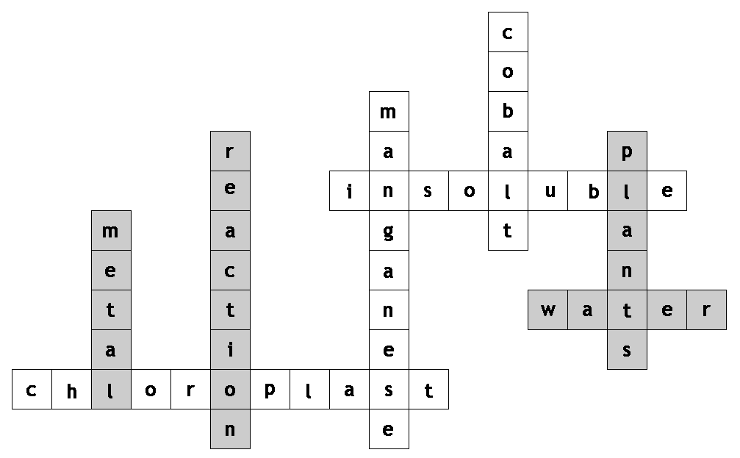

The unshaded squares are the answers to the first four clues.
The shaded squares are suggested answers from the text for which students should write clues for.
Plenary 1
What am I? — PowerPoint

