Week 5 Lesson 2
Wind turbine blades
Aim: To carry out a biomimicry based investigation.
Keywords: drag, lift, turbine, vortex

Starter activities
The starter activities can be found on the PowerPoint ‘Wind turbine blades’.
- What am I?
A quick ‘yes/no’ game in which students should find out that whales are the inspiration for the rotor blades (slides 2-3).
- Bumpy or smooth?
A brief introduction to research that has led to the discovery that bumpy edge fins are more efficient than the traditional smooth surface (slides 4-6).

Main activity
- Investigation — Comparing designs for a helicopter blade
Students have the opportunity to try out their own investigation based on biomimicry.
Assessment opportunity
Assess students’ investigation skills e.g. planning, taking measurements, drawing conclusions and evaluating the practical as well as working as a team.

Plenary activities
- Investigation findings
Ask students to report back their findings from their investigation. This is an opportunity to assess their understanding of what makes a fair test and what reliable and accurate results are.
- Recent rotor blade research
Find two short activities on the PowerPoint ‘Wind turbine blades’ (slides 9-12). They are both based on short videos about current research in rotor blades and wind turbines.
Starters 1 and 2 / Plenary 2
Wind turbine blades — PowerPoint

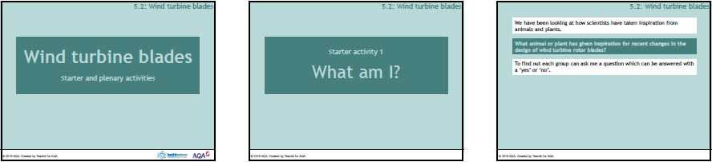

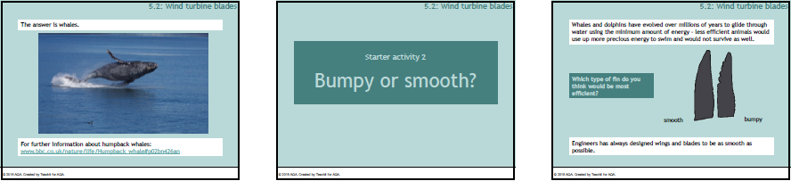

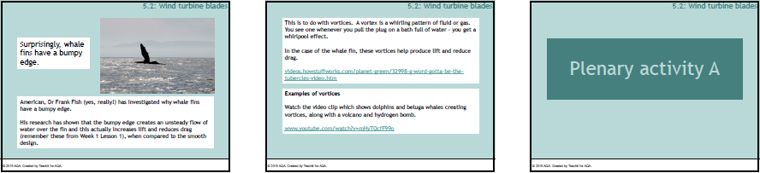

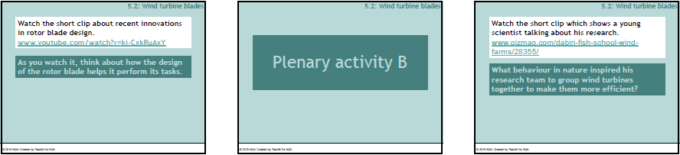

Main 1
Investigation — Teaching notes
This may involve students standing on tables to gain maximum height – you will need to carry out a risk assessment.
The investigation allows an opportunity to introduce/reinforce the terms repeatable, accurate and precise.

Differentiation
For students who need some support, provide pre-drawn or pre-cut helicopters to ensure the 'blades' are the same area.

Extension
As they begin the practical more able students can be asked what they are assuming as they start dropping their helicopters.
• Why is it necessary to drop from the same height? Can they make a prediction – explain why x is more likely than y?
• When they have results, can they explain them in terms of forces or air resistance?
• Could they test the whale fin design of a wind turbine blade in the school lab? If yes, how would they go about it?

Suggested answers
Questions
- a) Repeat readings and take an average, check readings from other groups, have more than one person take the readings.

b) Dropping the helicopter from exactly the same height, using a stopwatch that is sensitive enough, taking readings that are to an appropriate number of decimal places.

- Sycamore seeds need to carry the seed away from the tree a short distance to ensure the seedling grows in the light and not in the shade beneath the parent tree canopy. A helicopter is required to ascend, descend, hover and move forward and backwards.
Investigation — Comparing designs for a helicopter blade
You are going to investigate whether altering the design of a helicopter blade could enhance its performance. You will compare the performance of a traditional shape with a sycamore seed shaped blade.

Equipment
- graph paper
- scissors
- 2 paper clips
- stop clock

Method
- Copy the template onto graph paper. You will need two.
- Cut out and fold to build a model helicopter. Put to one side for now.
- Look at the images of sycamore seeds you produced for homework.
- Decide on a design for the 'wings' of your second model.
- Draw this on both wings of your model, making sure each wing ends up the same shape and orientation, and cut out – collect all the pieces you have cut away.
- Using the pieces you have collected, work out the area of paper you have cut away.
- By cutting across the ends of the wings of your first helicopter model, remove the same area of paper.
- You should now have two helicopter models; one with square ended wings and the other with sycamore seed shaped wings but the wings should all be the same area to make your test fair.
- Test your helicopters by dropping from a height and measuring how long they take to fall, or by dropping both helicopters simultaneously and recording which reaches the ground last.

Questions
- Any differences in the time taken will be small and difficult to measure. How could you increase the chances of producing results you can trust – i.e. that are a) reliable b) accurate?
- Why do you think helicopter blades are not the same design as sycamore seeds?

Investigation — Template
