Week 5 Lesson 3
Silk moths and chitin
Aim: To understand why plastics are so useful; why they are a problem in the environment and where scientists are looking to find replacements for petroleum based plastics.
Keywords: biodegradable, chitin, invertebrate, monomer, polymer

Starter activities
- Compare plastics and chitin
Introduce the idea that nature may offer replacements to petroleum based plastics. The PowerPoint, ‘Silk moths and chitin’, helps students’ make connections between the two materials.
- Polymers
Explain that plastics and chitin are polymers, formed from single units known as monomers. You can model a polymer by linking together paper clips. Ask students to list the properties of plastics.

Main activities
- Under the microscope
If possible view invertebrate specimens under a microscope to see the exoskeleton. To save time set the microscopes up before the lesson. Ask students to think about the following questions.
- What structures does the exoskeleton form?
- What properties does it have?
- How many of these properties does it share with plastics?
- Comparing polymers

Try the activity, ‘Comparing polymers’, in which students compare and contrast the properties of chitin and petroleum based plastics.
Differentiation and extension
Provide students who need support with a table of suitable headings to help them sort the statements. There are three questions on the sheet which use different command words, i.e. describe, compare and evaluate. Assign different students one or all of the questions to answer. It is a good opportunity to discuss what each of the command words is asking for.
- Shrilk
Students plan a pitch which outline the benefits of a new product called Shrilk, made from chitin and silk, using the resource ‘Shrilk’.
- Polymer practical
The Royal Society of Chemistry website (http://www.rsc.org/learn-chemistry) has a number of classic demonstrations and practical activities based on polymers such as making and testing 'slime'. There is a mathematical skills resource, ‘Maths and measuring volume’, to accompany this practical (or as a standalone activity) which could be easily adapted to use with other experiments.
www.rsc.org/learn-chemistry/resource/res00000756/pva-polymer-slime

Assessment opportunity
The maths activity provides an opportunity to assess students’ basic number skills.

Plenary activity
- Match the Greek word with its meaning
Many of the words we use today have their roots in ancient languages such as Greek and Latin. Use the ‘Matching’ activity on the PowerPoint to pair the Greek words with their meaning.
Greek word | Meaning
plasticos | to mould
khitōn | tunic
skeletos | dried up
organikos | relating to an organ or instrument
exō- | outside
polumeros | having many parts

Ask students which words used in the lesson originate from these Greek words?

Starter 1
Silk moths and chitin — PowerPoint

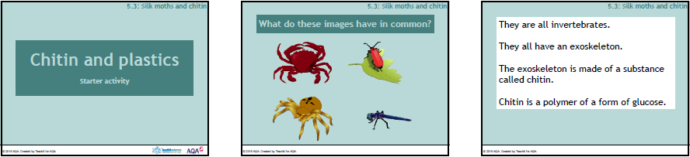

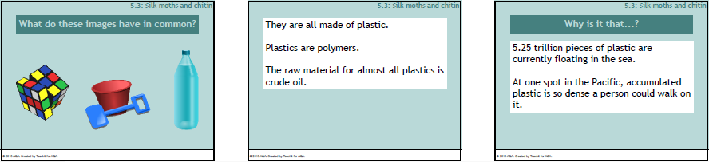

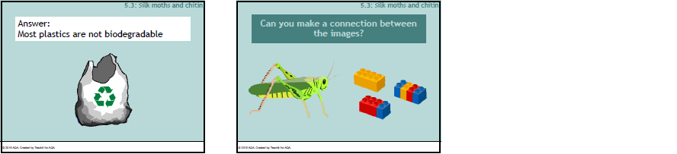

Main 2
Comparing polymers
Look at the statements below which show some of the properties of plastics and chitin. Cut up the statements and sort them into groups to show the similarities and differences between the properties plastics and chitin.

Use the statements to help you answer the following.
- Describe the advantages of using plastic bottles for storing chemicals.
- A company manufactures disposable cutlery. Compare the advantages of using chitin or plastics to make the cutlery.
- Evaluate which material, chitin or plastic, would be best to use in the manufacture of a toy aimed at toddlers.

resistant to chemicals and water | electrical and thermal insulator
high strength-to-weight ratio | most are non-biodegradable  but can be recycled
durable | can be moulded into any shape
additives to plastic can be toxic | can be coloured
Properties of petroleum based plastics:

Properties of chitin:
resistant to water and some chemicals | insulating properties are currently being investigated
can be coloured | non-toxic
can form many shapes | biodegradable
durable | high strength to weight ratio
Main 3
Shrilk
Many scientists are searching the plant and animal worlds in the hope of finding a material that has all the properties of petroleum-based plastics, yet is also fully biodegradable.
They have turned to the world's second most abundant organic polymer – chitin.
By combining chitin from shrimp shells and fibroin (a protein from boiled silkworm pupae), they have produced Shrilk.
Now, they need to get their new product out into the manufacturing world.
Can you persuade business to begin manufacturing Shrilk?

Task
You have been asked to attend a Plastics convention and trade exhibition at the NEC, Birmingham. You will have a trade stand and displays showing your new product. Can you seize the interest of passing business delegates and talk them into backing your product, Shrilk?
Use the statements below to help build your pitch.

- Shrilk is tough
- Its flexibility can be altered by adjusting the water content
- It is flame retardant
- Shrilk can be injection moulded
- Chitosan (a derivative of chitin) can be stamp-moulded
- It can be transparent, translucent, opaque
- It is a thermal insulator
- The raw materials for Shrilk are the waste products from other industries
- It is fully biodegradable, forming a fertilizer which can be put on the land.

- What is Shrilk's USP (unique selling point)?

- How do you think the cost of manufacturing Shrilk will compare to the cost of traditional plastics?
Main 4
Maths and measuring volume — Answers

  - 10 cm³ x number of students in class
  - 40 cm³ x number in the class

  - 6 students
  - 12 students
  - Answer will depend on the number of students in the class
- 15 cm³

- 2.5 cm³
Maths and measuring volume
These questions are based on a practical to make polymer slime. To make the slime each group needed 40 cm³ of polyvinyl alcohol and 10 cm³ of borax solution.

- What would be the minimum amount of a) borax solution b) polyvinyl alcohol needed to make sure that everyone in the class has enough for their experiment?

- On the day of the experiment the technicians could only make up 240 cm³ of polyvinyl alcohol.
  - How many students could carry out the experiment individually?
  - How many if they worked in pairs?
  - How large would each group have to be if everyone were to be involved?
- One member of the class used 60 cm³ of the polyvinyl alcohol instead of 40 cm³. How much borax solution would they need to add to make the correct mixture?

- There is enough polyvinyl alcohol if everyone uses only 10 cm³. How much borax solution should be added to this?

Maths and measuring volume
These questions are based on a practical to make polymer slime. To make the slime each group needed 40 cm³ of polyvinyl alcohol and 10 cm³ of borax solution.

- What would be the minimum amount of a) borax solution b) polyvinyl alcohol needed to make sure that everyone in the class has enough for their experiment?

- On the day of the experiment the technicians could only make up 240 cm³ of polyvinyl alcohol.
  - How many students could carry out the experiment individually?
  - How many if they worked in pairs?
  - How large would each group have to be if everyone were to be involved?
- One member of the class used 60 cm³ of the polyvinyl alcohol instead of 40 cm³. How much borax solution would they need to add to make the correct mixture?

- There is enough polyvinyl alcohol if everyone uses only 10 cm³. How much borax solution should be added to this?

