Week 3 Lesson 2
Desalination

These activities should take about 1 ½ lessons.
Aim: To show how fresh water can be obtained from salt water and how this process happens in the natural world.
Keywords: aquifer, condensation, distillation, evaporation, hypotonic, hypertonic, osmosis, precipitation, proteins, semi-permeable membrane, solution, water cycle

Starter activities
- Homework recap
Students use the homework which was set in preparation for the lesson. They can read their partners’ work and then tell the class about it.

- How does nature provide us with fresh water?
Sketch and label the diagram of the water cycle (see PowerPoint).
Discuss how snow melt in the mountains during warmer months provides many communities downstream with a constant supply of fresh water during the summer when there is little rainfall. Global warming is causing snow fields and glaciers to melt. In time, this source of fresh water may diminish or disappear completely.
The video students watched for homework mentioned aquifers. Explain what these are and how bore holes have been sunk into underground water sources. Often, water is being extracted faster than it is replenished by seepage through rocks from the ground above. Saline water can move in to replace the fresh water removed in this way.
And on a smaller scale, how does water move in and out of cells?

Main activities
- World’s population without safe drinking water
The following activity illustrates the difficulty for many people across the globe of having access to safe, clean drinking water. It also provides an opportunity to develop students’ mathematical skills. Use the PowerPoint, ‘World’s population and water’, and invite students up to write their answers on the interactive whiteboard. Students will each need access to a calculator.

Differentiation
Students who need some support could work out the population in whole numbers whereas others could work out the population in standard form.

Assessment opportunity
The activity provides an opportunity to assess the confidence of students when making estimates, rounding numbers, calculating percentages and working in standard form.

- The process of desalination
Freshwater can be produced by taking salt out of seawater, desalination. It uses physical processes, evaporation, condensation and osmosis. Explore different methods of desalination in these two practical activities.

Practical 1: Osmosis demonstration
N.B. This demonstration needs to be prepared well in advance of the lesson. Remove the shell from 2 chicken eggs by dissolving the shell in acetic acid. This will take 2 – 3 days.
Preparation steps
- Find the mass of each egg.
- Place one egg in a hypotonic solution and the other in a strongly hypertonic solution.
- Leave for at least 8 hours.
- Find the mass of each egg.
Explain the egg is a single cell. Beneath the shell is a semi-permeable membrane. The egg contains water, salts and large molecules such as proteins. Water moves across the membrane, from an area of high concentration to an area of low concentration. This is known as osmosis.
Explain that there are two methods of desalination by osmosis that are used- reverse and forward osmosis.
Reverse osmosis
Pressure is applied to push water through a semi-permeable membrane. The membrane is designed to prevent larger solutes from passing through.
Problems: It requires a lot of energy and is expensive. The membranes become clogged with bacteria and they deteriorate when chlorine is used to kill the bacteria.
Forward osmosis
A semi-permeable membrane separates the saline water from a highly concentrated solution of ammonia salts. Water molecules move across the membrane into the highly concentrated solution.
The ammonia solution is heated to evaporate the ammonia salts which are collected and reused.
This is a relatively new technology and needs funding for further research and development.

Differentiation
Ask students to draw annotated diagrams to describe (or explain) one of the types of osmosis used in desalination.

Extension
Students could annotate diagrams to compare the advantages and disadvantages of the two methods.
To see the latest developments watch the following clips.
The first shows how proteins are being incorporated into membranes:
www.youtube.com/watch?v=1zcEYYRtSnE
A short clip showing how graphene is used to make a filter:
www.youtube.com/watch?v=k5Tjy_90WBU
Practical 2: Distillation demonstration
Set up a demonstration (or student practical) to show how pure water can be distilled from salty water.
Explain that desalination by distillation requires a great deal of energy to heat the water. The idea of specific heat capacity of water could be explored at this point.
This illustrates that desalination by distillation requires a great deal of energy and is expensive. The cost of building and maintaining these facilities is also very high.

Plenary activity
- What’s the question?
Put the answers on the board – students write the question
    - The water cycle.
    - A natural store of underground water.
    - By distillation.
    - It allows water to pass into and out of cells but not large molecules such as proteins.
    - Osmosis.
    - These are all disadvantages of desalination by distillation.

Starter 2
How does nature provide us with fresh water? — Answers
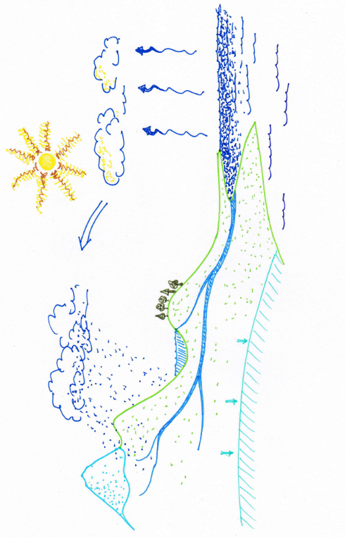
condensation
aquifer
run off
transpiration
precipitation
evaporation
Main 1
World’s population without safe drinking water

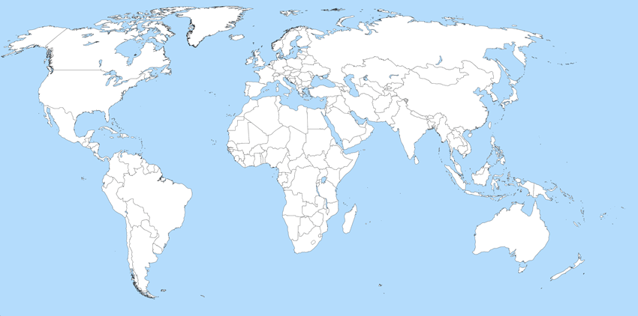

Main 2
World’s population without safe drinking water — PowerPoint

