Week 5 Lesson 1
The Bombardier beetle
Aim: Explore an aspect of chemistry found in an organism which is being researched by scientists.
Keywords: catalyst, chemical reaction, evolution, exothermic

Starter activity
- Scientist — who’s who?
Match the scientist with their areas of research and other achievements.

Main activities
- Charles Darwin and the Bombardier beetle
The following activities are on the PowerPoint ‘The Bombardier Beetle’:
- The story of Charles Darwin’s encounter with a Bombardier beetle
- Sequence the possible stages of evolution of the Bombardier beetle’s defence mechanism
- Practical – exothermic reaction.

Plenary activity
- Haiku
Students sum up the lesson or part of the lesson by writing a three line Haiku.
The first line should have 5 syllables, the second 7 and the third 5. Subjects could be Darwin, bombardier beetle, exothermic reactions, catalysts.
E.g. Charlie learnt one truth
when out hunting for beetles.
Bug in mouth - no fun!

Differentiation
Students who need support could be given a selection of words with syllables counted or marked by dots.
Week 5 homework activity
This task is in preparation for lessons next week on artificial photosynthesis. Students are asked to produce a PowerPoint which will be shown in the lesson next week. Assign each student a task or ask them to choose one. Tell them that the PowerPoints that they create will be shown in class the following week.

- Design a PowerPoint presentation which shows the substances that are involved in photosynthesis. Use a maximum of six slides.
- Design a PowerPoint presentation which describes the process of photosynthesis. You are allowed to use mathematical symbols, three words only and a maximum of three slides.
- Design a PowerPoint presentation which explains photosynthesis cryptically. Think of clues which Sherlock Holmes might decipher to give each part of the process. Use a maximum of six slides.

Starter 1
Who’s who? — Teaching notes and answers
This is a tiny snapshot of scientists that students may have heard of, both historical and contemporary. For further information about inspirational scientists see the following links:
- For influential women scientists both historical and contemporary see this article from The Independent: www.independent.co.uk/news/science/women-in-science-pioneers-blaze-path-for-others-1924794.html
- The Life Scientific programme from Radio 4 has lots of interviews with current scientists: www.bbc.co.uk/programmes/b015sqc7
- The Royal Society webpage Inspiring Scientists: Diversity in British Science, records the life stories of 10 British scientists with minority ethnic heritage: royalsociety.org/policy/projects/leading-way-diversity/inspiring-scientists/
Caroline Herschel  born 1750 died 1848 | Astronomy – discovered 8 comets and catalogued star clusters  The first female scientist to be paid a salary
Stephen Hawking  born 1942 | Cosmology and theoretical physics, author of A brief history of time
Dr Maggie Aderin-Pocock, MBE  born 1968 | Space science, optical instrumentation  Presenter of the The Sky at Night, MBE awarded 2009
Baroness Susan Greenfield, CBE  born 1950 | Professor of Synaptic Pharmacology at Oxford University  Member of the House of lords
Rosalind Franklin  born 1920 died 1958 | X-ray crystallography, important contribution to understanding of DNA structure in the 1950s.
Brian Cox, OBE  born 1968 | Professor of Particle Physics at University of Manchester  Writer, TV presenter and keyboard player for 80s pop group D:Ream
Alice Roberts  born 1973 | Clinical anatomist and Professor of Public Engagement in Science at the University of Birmingham  Writer and TV presenter.
Peter Higgs  born 1929 | Proposed the existence of a particle called Higgs boson; Nobel prize in Physics 2013
Dorothy Hodgkin  born 1910 died 1994 | Biochemistry and protein crystallography – discovered the structure of penicillin and vitamin B12: Nobel Prize for Chemistry 1964
Isaac Newton  born 1643 died 1727 | Physics and mathematics, discovered laws of gravity and motion
- The Royal Society of Chemistry has a series of short videos which ask inspirational scientists working in chemistry what motivated them to study chemistry: www.rsc.org/learn-chemistry/collections/faces-of-chemistry/inspirational-chemists

Who’s who?
Scientist | Areas of research and some achievements
Caroline Herschel  born 1750 died 1848 | Space science, optical instrumentation  Presenter of the The Sky at Night, MBE awarded 2009
Stephen Hawking  born 1942 | Professor of Synaptic Pharmacology at Oxford University  Member of the House of lords
Dr Maggie Aderin-Pocock, MBE  born 1968 | Cosmology and theoretical physics, author of A brief history of time
Baroness Susan Greenfield, CBE  born 1950 | Clinical anatomist and Professor of Public Engagement in Science at the University of Birmingham  Writer and TV presenter.
Rosalind Franklin  born 1920  died 1958 | Proposed the existence of a particle called Higgs boson; Nobel prize in Physics 2013
Brian Cox, OBE  born 1968 | Biochemistry and protein crystallography – discovered the structure of penicillin and vitamin B12: Nobel Prize for Chemistry 1964
Alice Roberts  born 1973 | Physics and mathematics, discovered laws of gravity and motion
Peter Higgs  born 1929 | X-ray crystallography, important contribution to understanding of DNA structure in the 1950s.
Dorothy Hodgkin  born 1910 died 1994 | Professor of Particle Physics at University of Manchester  Writer, TV presenter and keyboard player for 80s pop group D:Ream
Isaac Newton  born 1643 died 1727 | Astronomy – discovered 8 comets and catalogued star clusters  The first female scientist to be paid a salary
Use the information to match the scientist to their area of research and achievements.

Main 2
The Bombardier beetle – PowerPoint

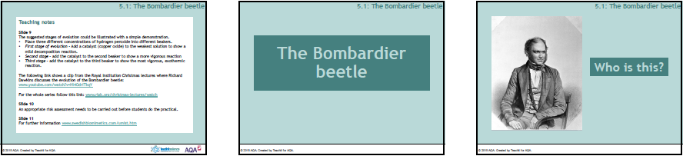

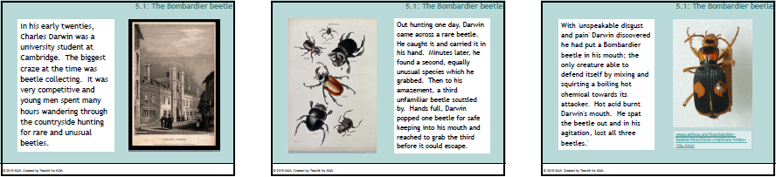

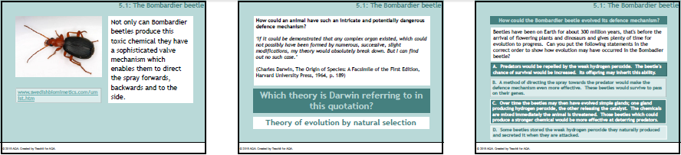

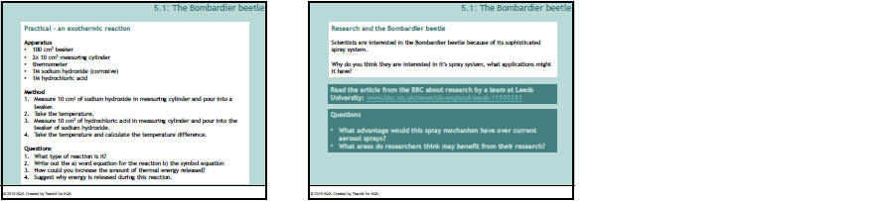

Week 5 homework
Preparation for photosynthesis
Choose one of the following tasks
- Design a PowerPoint presentation which shows the substances that are involved in photosynthesis. Use a maximum of six slides.

- Design a PowerPoint presentation which describes the process of photosynthesis. You are allowed to use mathematical symbols, three words only and a maximum of three slides.

- Design a PowerPoint presentation which explains photosynthesis cryptically. Think of clues which Sherlock Holmes might decipher to give each part of the process. Use a maximum of six slides.

Week 5 homework
Preparation for photosynthesis
Choose one of the following tasks
- Design a PowerPoint presentation which shows the substances that are involved in photosynthesis. Use a maximum of six slides.

- Design a PowerPoint presentation which describes the process of photosynthesis. You are allowed to use mathematical symbols, three words only and a maximum of three slides.

- Design a PowerPoint presentation which explains photosynthesis cryptically. Think of clues which Sherlock Holmes might decipher to give each part of the process. Use a maximum of six slides.

