Week 4 Lesson 1
Neural networks
Aim: To use modelling to understand what is meant by a neural network and link this to how computers function. To see what factors can influence the progress of research.
Keywords: artificial and biological neural networks, neurone, synapse, threshold level

Starter activities
Ask students to put aside their pencil cases – this is a pen and paper free lesson.
- The brain – true or false?
Read out the questions from the resource ’The brain – true or false?’ There is also a PowerPoint quiz version (‘Neural networks’) and ask students to give their answers with a show of hands. Share the answers with the students.
Ask students to suggest which scientific fields of study might be linked to how the brain works. This lesson links neural networks with the field of computing.
- Plenary preview
Show the plenary and explain that this is what they will do at the end of the lesson. It is on slide 12 of the PowerPoint ‘Neural networks’.

Main activities
- Constructing a neural network
The students make model neurones and arrange them into a network. The model network can be used to explain how we learn.
- A brief history of neural networks
Show the students the sheet 'A brief history of neural networks'. Ask them to read it and find examples of why research slowed down or stopped.
What do they think of these reasons?
Suggested answers: Public opinion, the influence of the media, lack of money, lack of government support, the opinions of other scientists and lack of concurrent development in supporting technologies such as processors.

Plenary activity
- Neural networks summary
Ask students to choose one of the following. Ask them to answer verbally.
- Summarise what you have done in this lesson.
- Say two things you have learnt in this lesson and describe how your brain has done this.
- Explain how brains and computers are similar and different.

Differentiation
Students choose one of the sentences above according to ability/confidence.

Week 4 homework activity
The homework is in preparation for Week 5, lesson 2 ‘Wind turbines’. Students should be assigned the most appropriate task, depending on ability.
Ask students to select and print off two images of a helicopter rotor blade (they could find an image of the cross section of a rotor blade too) and also two images of sycamore seeds.

Differentiation
Assign each student one of the following tasks:
- List one similarity and one difference between the rotor blade and the seed.
- Describe the similarities and differences between the rotor blade and the seed.
- Describe the similarities and differences between the rotor blade and the seed and describe the functions of a rotor blade and a sycamore seed.
There are three versions of the homework sheet to give out to students.

Starter 1
The brain — true or false? Questions and answers
- When mummifying people, Egyptians would remove the brain through a hole cut in the top of the skull.

False – they pulled the brain out through the nose

- You only snore when you are dreaming.

False

- The first sense to develop in an embryo is touch.

True

- 60% of your brain is fat.

True – essential fatty acids omega-3 and omega-6 cannot be manufactured by the body. They are linked to brain functions such as memory, speech and motor skills

- There are 12 000 chemical reactions happening in your brain every second.

False – the figure is 100 000 every second

- The pathologist who carried out the autopsy on Einstein's body stole the brain and kept it in a jar for 20 years.

True – apparently it was stolen, cut into 240 pieces and preserved. For a time it was kept in a box under a beer cooler. The removal was carried out against Einstein's wishes – expressed before he died.

- The brain is composed of about 10 billion neurones.

True.

- Each neurones in the brain is connected to 1 000 other neurones.

False – each neurone has connections with about 10 000 neurones.

- You had more nerve cells in your brain when you were 2 years old than you will have at any other time in your life.

True – shortly after birth there is a substantial increase in the number of nerve cells in certain parts of the brain. This increase stops at around 24 months except in the hippocampus. The majority of our nerve cells are as old as we are. They are not replaced when they fail.

- There are no pain receptors in the brain.

True
Starter 1 and 2
Neural networks — PowerPoint

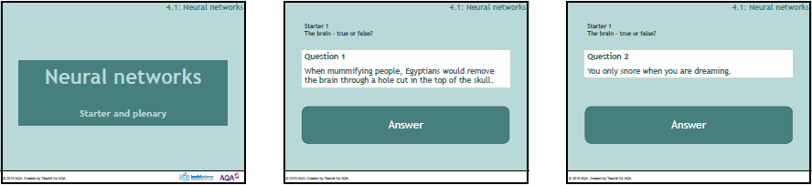

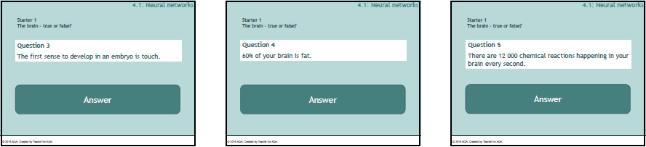

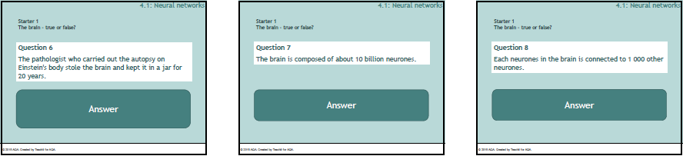

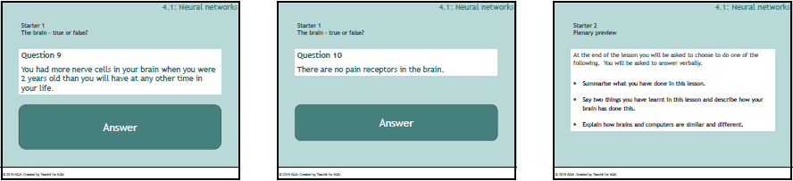

Main 1
Constructing a neural network — Teaching notes
Materials needed per group
- old over the knee length socks or tights
- balloons
- newspaper
- cotton thread
- toilet tubes
- elastic bands
- scissors
Using discarded over-the-knee length socks or tights, students make a model neurone. Winter weight tights are probably best.
Demonstrate how to make a model neurone by following the instructions.

Model neurone instructions
- Blow up a small balloon (or scrunch paper into a ball). This represents the cell body containing the nucleus.
- The balloon can remain in the 'hip' section of the tights, with the opening at the waist sewn or tied to secure it and the legs stretched out, to represent a sensory neurone. Otherwise, cut the legs off the tights and push the balloon into one end of a leg.
- Tie off close to the balloon, leaving enough material (20 - 25 cm) to make the dendrites. Cut this material into strips, twist and tie a knot in the end of each to represent the dendrites.
- Cut the foot of the tights into strips 10 – 15 cm long. Use elastic bands to tie off each strip. These represent the axon terminals.
- If you like, toilet tubes can be threaded onto the 'axon' to represent the myelin sheath in a myelinated nerve cell.
If there are enough tights, students can work in pairs to produce a model neurone.
Using a variety of textbooks, students can research and identify the different parts of their neurone.
Then the model neurones can be laid out to show how they connect to pass impulses.

Neural network model instructions
Choose one neurone and lay it out on the floor. Spread out the dendrites and axon terminals.
The axon terminals of 2 – 3 other neurones can be put in contact with the dendrites of the first neurone.
Likewise, the dendrites of 2 – 3 neurones can be positioned close to the terminals of the original neurone.
Students continue to construct a neural network. Classroom furniture will inevitably get in the way. These obstacles can represent clusters of nerve fibres and supporting tissues.
Point out the junctions between nerves – the synapses - and explain how the impulse is transmitted across the synapse.
Use small sticky labels or Post-it notes to represent the arrival of an impulse. Explain how the arrival of a single, weak impulse will not be enough to generate a response in the receiving neurone.
The cell body must receive several impulses which combine as they pass over the cell body. If this combination is large enough to reach a certain threshold level, an impulse will be triggered in the receiving cell. A neurone will only fire if the total signal received by the cell body exceeds a certain level. Point out that this is important – a neurone either fires or it does not fire and link this to a digital signal which is 1 or 0 (on or off). The brain and a computer both operate using binary signals.
This impulse is transmitted along the cell's axon to the axon terminals where it is passed on to its neighbouring neurones.
Explain that when a neurone fires off an impulse, it strengthens its connections with the neurones it received the signal from. Making more and stronger connections with neighbouring neurones – this is how we learn.
So, the brain has a very large number of simple processing units (neurones).
Each neurone 'weighs up' the sum of its inputs and then produces a binary signal – it either fires or it does not.
With this simple system the brain performs extremely complicated tasks such as singing and walking and imagining the day ahead, all at the same time!

Going further
When this activity is completed ask someone to describe what a neural network is. Explain that this is the model scientists have tried to develop in computer systems. Work on artificial neural networks began early in the history of computing but it is not the method widely used by today's computers.
Most computers work by fetching a set of instructions from their memory and working through these instructions in a step-by-step, linear fashion. This is good for many tasks such as searching for an item in a database but is not good for tasks that people find simple e.g. recognising faces.
Artificial neural networks have been developed using the biological model of the brain we described earlier. These are much better at dealing with imprecise data and making predictions.
Why has the development of artificial neural networks been slower than its rival, the step-by-step network?
Main 2
A brief history of neural networks
1943 | The first simple model of a neural network was made with electronic circuits.
1949 | It was realised that neural networks in the brain are strengthened each time they are used.
1959 | First neural network was used to solve a problem (removing background noise from phone land lines)  There was much anxiety amongst the general public about world domination by intelligent robots.  Newspapers and radio became very excited about these developments. Many exaggerated claims were made. There was much 'hype' followed by huge disappointment when neural networks failed to meet expectations.
1969 | Respected scientists began to criticise the neural network model. Money for research began to dry up.
1982 | Newspapers generated a worry that the USA could be left behind as Japan announced more research on neural networks. Funding was increased.
1986 | Complex 'multi-layered' networks were developed but the computers were slow-learners because the processors were too slow. The technology needed to support the neural network was not available.
2000 | Fuzzy logic* was integrated into neural networks and these are now used to screen job applications and monitor medical conditions such as glaucoma.

*Fuzzy logic can use more than just simple true/false values and therefore is better at simulating the real world e.g. the statement 'Sam wore his school blazer today' might be 100% true if he wore it all day, 80% true if he wore it until last lesson, 50% true if he took it off at lunch, 0% true if he left it on the bus in the morning.
Week 4 homework

- Select and print off the following:
    - two images of a helicopter rotor blade
    - two images of sycamore seeds.
- List one similarity and one difference between the rotor blade and the seed.

Week 4 homework

- Select and print off the following:
    - two images of a helicopter rotor blade
    - two images of sycamore seeds.
- List one similarity and one difference between the rotor blade and the seed.

Week 4 homework

- Select and print off the following:
    - two images of a helicopter rotor blade
    - two images of sycamore seeds.
- List one similarity and one difference between the rotor blade and the seed.

