Week 3 Lesson 3
Freshwater in deserts

This lesson should take about 30 – 35 minutes.
Aim: To see how fresh water can be obtained by condensation.
Keywords: condensation, desert, filtration, precipitation

Starter activities
- Keyword quiz
Ask the class to come up with key words from the previous lesson.
Award one point for each appropriate word. Say you are looking for particular words and these are worth more points.
- Two words which begin with the letter 'D' = 5 points each
e.g. desalination, distillation
- Two beginning with the letter 'H' = 10 points each
e.g. hypotonic and hypertonic)
- One with a hyphen = 15 points
e.g. semi-permeable membrane
- Can they exceed a total of 50 points?
- Missing vowels
An activity based on a round from the quiz show ‘Only Connect’. Give students a keyword from last lesson with the vowels removed and the consonants regrouped.
- dsl ntn (desalination),
- dstl ltn (distillation),
- h ypt nc (hypotonic),
- h ypr tnc (hypertonic),
- wt rcy cl (water cycle),
- cn dn stn (condensation) etc.

Main activity
- Namib beetle
Recall that we have seen how fresh water can be obtained from seawater, naturally during the water cycle and by desalination in large processing plants.
Recall that clean, fresh water is vital for everyone and, unfortunately is a diminishing resource.
Use the PowerPoint, ‘Freshwater in deserts’, to link to 4 short clips about a novel way of collecting water based on the drinking habits of the Namib beetle. Students will need the copy of their map from the previous lesson.

Plenary activity
- Questions and answers
Copy the sheet and cut up the questions and answers. Give each student either a question or an answer. They have to find their partner.

Differentiation
Some questions are easier than others so give them out to the appropriate students. Students could team up to find their answers.

At the end of the activity ask who has a question about osmosis. There are two which involve osmosis. Ask the students who have them to read them out – can anyone describe osmosis?
Main 1
Freshwater in deserts — PowerPoint
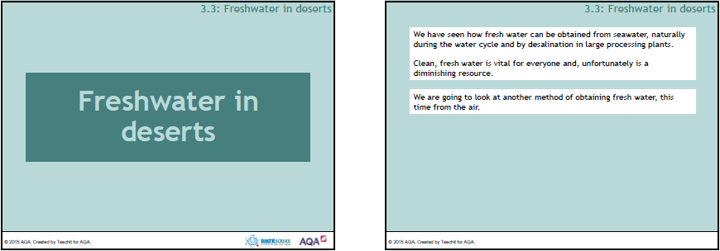

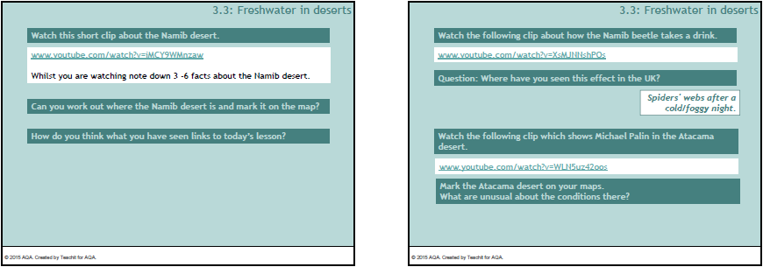

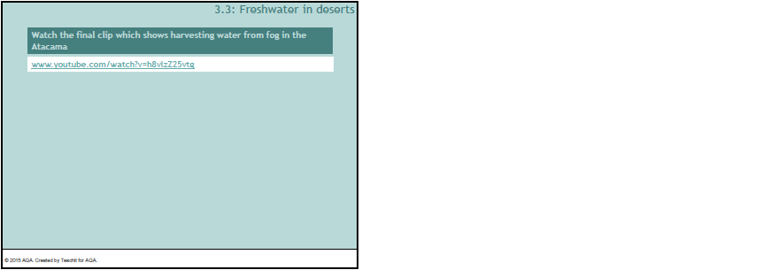

Plenary 1
Questions and answers
What is a solution? | This is formed when a solute dissolves in a solvent.
How can pure water be separated from seawater? | It can be separated by distillation.
What process enables farmers in the Atacama desert to collect fresh water? | Condensation of water droplets onto nets.
What does 'soluble' mean? | It means that the substance will dissolve.
Which part of the water cycle is caused by energy from the sun? | Evaporation.
What does a solvent do? | This will dissolve a solute.
Where would you find water-harvesting nets? | On foggy hillsides close to the sea.
How is the Namib beetle adapted to collect fresh water? | The surface of its back is bumpy. Water condenses on the bumps.
Can you describe osmosis? | No, but I know someone who can.
What is another word for 'rainfall'? | Precipitation.
What is the name for the process of water vapour entering the atmosphere from plants? | Transpiration.

How can solid particles be separated from seawater? | They can be separated by filtration.
How does water enter and leave a cell? | By osmosis.
Will solutes always dissolve in a solvent? | No, solutes are only soluble in certain solvents.
What type of substance is a solution? | It is a mixture.
What is an 'aquifer'? | An underground source of water which is often saline.
Where would you find desalination plants? | By the sea, usually in hot countries.

